**Illustrative programs**

**3)** exponents in Python

**How to find EXPONENTIATION of an number**

Value=2

Exponent=4

Exponentiation 2 the power of 4

= 2^4

= 2x2x2x2

= 16

**Source code :**

1. “””
2. Exponents in Python
3. “””
4. #create a variable named value and exponents
5. value = int(input(“Enter a value : “))
6. exponents = int(input(“Enter a Exponents : “))
7. spar = value # spar is stored value variable
8. #create a for loop in range fix a exponents value
9. for i in range(1, exponents):
10. spar = spar * value
11. #Display a exponents value
12. print(“exponents is : “, spar)

**Output :**

**Enter a value : 2**

**Enter a Exponents : 4**

exponents is : 16

**Algorithm :**

1)start

2)if the condition spar is equal to value then read the base number of value

3)and read the base number of value, from the power of exponentiation

4)then read the exponent number of exponents, then the condition of I is equal to 1 to exponents

5)then compute the value of spar is equal to value ‘ spar

6)and then finally print ‘exponent’ as spar

7)stop

**Proof :**

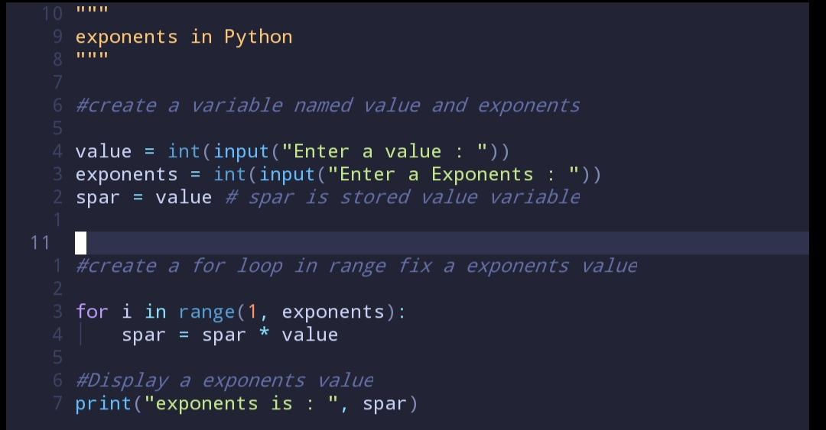**Source code :**

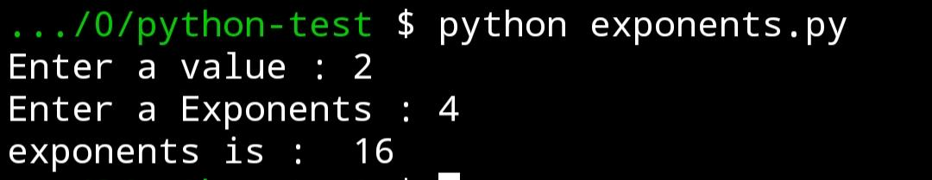**Output :**